

Project Plan

Team 29



University of Sussex



Contents

Plan outline 2

Introduction/Requirements analysis 2

Design Document 2

Coding simulation/GUI creation 2

Testing Phase/Final Documentation 2

Gantt Chart 3

Critical Path consists of: 3

# Plan outline

Our project is planned to take 12 weeks, following this structure below:

# Introduction/Requirements analysis

The introduction phase will be dedicated to the meeting the team and getting the foundation of project built. The foundation includes an online communication platform where all team member can have access to regularly. We also set up a google drive for document sharing and GitHub for the code sharing. This initial step should take 4 days. The next step is produce a plan outline which consists of the required tasks with the overall project time. We will also create a risk assessment document which outlines the possible issues that can arise and how they can be solved. The main part in the introduction stage is to produce a system requirement from the user requirement we are given. this should take around 8 days to complete because we need to separate the functional, non-functional and domain requirements. This part is important because the project will be based on the requirements documents. The introduction part will be taken as a whole team. The introduction stage should take around 17 days in total.

This section falls into the critical project path.

# Design Document

After the 17 days of introduction documentation, we will start the design stage where design such as class diagram, use case, sequence diagram will be created from the requirements document, the user interface design documentation will also be created in detail so that programming the simulation will be made easier. The design stage should take 25 days, this is because the designs will help the programmers code the simulation to a higher quality and meet the requirements.

This section falls into the critical project path.

# Coding simulation/GUI creation

After the low-level class diagram, use case diagram and sequential diagram then the coding phase can start where the code functionality can be implemented and the same time the user interface design documentation is being produced. The code functionality stage should take around 10 days with the user interface coding to take 10 days as well. While coding is taking place, the programmer will also be commenting the code so a java documentation can be produced. The whole coding process to take around 20 days to complete. The coding will be done by Levi and Jamie with the input of the team weekly.

This section does not fall into the critical project path.

# Testing Phase/Final Documentation

The testing phase should take 19 days to complete. This will include doing a unit testing and system testing and producing the final documentation which includes peer assessment and report. This stage will be done by the whole team but mainly the coding team of Levi and Jamie this is because they will test the function and the rest of the team will match the outputs to the user requirements.

This section falls into the critical project path

# Gantt Chart

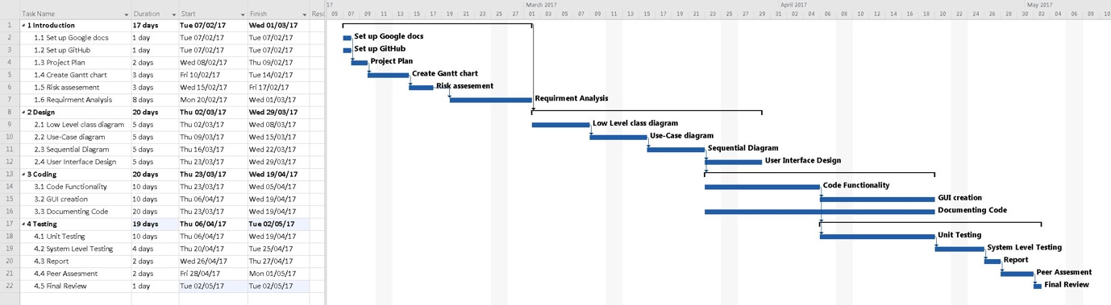

## Critical Path consists of:

The project should take a maximum of 12 weeks to complete including documentation and submission of project.

1. **Introduction**
   1. Set up Google docs
   2. Set up GitHub
   3. Project Plan
   4. Gantt chart creation
   5. Risk assessment
   6. Requirement analysis
2. **Design**
   1. Low level class diagram
   2. Use case diagram
   3. Sequential diagram
   4. User interface design
3. **Testing/Final documentation** 
   1. Unit testing
   2. System level testing
   3. Report
   4. Peer assessment
   5. Final review

*(There is a Microsoft project 2016 document containing the Gantt chart and a full picture of the Gantt chart in the folder.)*